Tip Sheet for Providers – How to send a staff message to Patient Navigators
When needing to request records, appointments, or other items the hospital navigators need to assist with, the best way (that is trackable) is through your Epic Inbasket Staff messages.
When and why should I send a staff message? If you are needing to request navigator assistance, you should send a staff message. Your message will go to a pool of users then get forwarded to the assigned navigator. Navigators only assist patients in the ED and on the medical units (no outpatient areas). Common Navigator Requests:
- arrange outpatient appointments for hospital followup at UTSW and in the community
- request records (reports or imaging) needed for medical decision making during the hospital stay
- assist with FMLA and letters requested by the patient (that you are willing to sign and provide input for).
For records, please send a message as soon as possible with the facility or provider name, location, timeframe of visit, and specific records you are looking for. For appointments, our goal is to arrange appointments prior to the patient leaving so the day before discharge is ideal for you to request our assistance. If you send a request when the discharge orders are in, the patient will likely leave without appointments; we will try our best to contact them by phone (if they do not answer or call us back, we cannot schedule any appointments – they must accept the appointment).
Navigators currently do not assist with all service lines. If you service line is not supported, we will attempt to forward your request to the support person for that team in the outpatient area.
Why can’t I use securechat? Securechat is not part of the patient record and messages expire after 4 days. Secure chat is not meant to be pulled into the patient record and more meant for informal discussion and for clarification. If you send a securechat to someone that is absent for the day, no one can access their messages.
How do I send a staff message? There are two ways to send a staff message. First is through the open hospital patient chart. The second is through your epic inbasket; using your inbasket will let you see your sent messages and also review any messages that have been sent to you in reply.
To send through an open hospital chart, it will automatically attach your patient to the message when you send it.
- Go to the downward triangle in the top right of your screen below “EpicCare” and left click.
- Then choose “Send Message”.
- Then choose “Staff”(All other options will go to a less used area and may be overlooked). 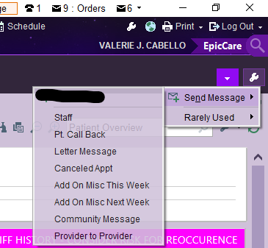
- If this is your first message to navigators, you will need to click on the magnifying glass and type “Navigator” in the “Pools” section, then click “Find”. Select NAVIGATORS (registry ID 11312) and click Add ‘To’ then Accept at the bottom right.
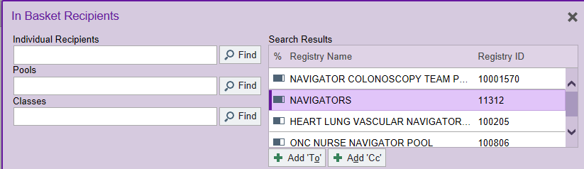
- This takes you back to your message, type in the text box what you are requesting then click “send” at the bottom.
Navigators check their inbasket messages at least once an hour. We prioritize requests based on discharge dates and urgency of the patient need. If you wait until the last minute to make a request, we may not be able to start working on it right away so please plan ahead. Each navigator often covers multiple units and multiple care teams. Please have patience. If the patient cannot leave the hospital without a particular appointment, please call your assigned navigator to discuss – they can be found on the care team and carry a spectralink. They are also available in secure chat for brief conversations. We do not use Vocera.

The alternate way to access your staff messages (to view your incoming and your sent messages) is to go to your InBasket. You can reach your inbasket by left clicking on the envelope icon at the top right of your epic screen. 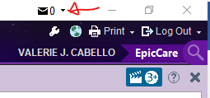

If you have any questions please reach out to Valerie Cabello, Assistant Manager in Care Coordination, Supervisor for the Hospital Patient Navigators, by phone 214-633-9784 or email Valerie.Cabello@utsouthwestern.edu.

