Parkland General Infectious Diseases Rotation
We are very excited to have you rotating with us on PHHS General ID. Our goal is for you to increase your knowledge and clinical skills in the management of infectious diseases as well as the appropriate use of antimicrobial therapy while experiencing the fascinating breadth and depth of amazing ID cases on display at our institutional sites. For general expectations and didactic schedule relevant to all ID rotations, please refer to the ID Rotation Expectations All Sites document. The Parkland General ID service covers those patients at Parkland not on the HIV or Bone and Joint (MSK) Services.
Rounding Room: Parkland 9th floor rounding room: 9.677, page ID fellow on call
The team:
- IDPharmacists: Jessie Ortwine (cell: 248-766-8141, x7-1807), Norman Mang (cell: 615-480-2690m x7-1810), Wenjing Wei (cell: 512-590-5039, x7-1808)
- Internal Medicine Residents – generally 2 per rotation
- Medical students and PA students – generally 1-2 per rotation
- Pharmacy students and residents – generally 0-2 per rotation
The fellow is ultimately responsible for knowing the patients on the service and helping to formulate plans.
- Residents should be assigned patients who can talk/give a history (ie: no intubated or altered patients)
- Try to have PAs, residents, and students follow the same patients continuously for continuity
Notes: Use the following note templates for all of your consult and follow-up notes:
- .GIDCONSULT (For new consults)
- .GIDFOLLOWUP (For follow-up notes)
Clinic Follow Up: Instruct the primary team to place an “OPAT consult” prior to the patient’s discharge if IV antibiotics will be prescribed. Patients may also be referred to the ID clinic for follow up if OPAT is not needed. Crystal Lawson is the scheduler for ID OPAT and ID clinic.
Micro plate rounds: Wednesday afternoon at 1 PM at the PHHS microbiology lab
Parkland Antibiogram: parklandlab.com
Helpful phone numbers:
Prefixes:
2-xxxx = 214-590-xxxx
3-xxxx = 214-633-xxxx
5-xxxx = 214-645-xxxx
7-xxxx = 469-419-xxxx
8-xxxx = 214-648-xxxx
Micro Lab: 7-4047

Parkland OPAT and Pharmacy Resources
Order Sets Available in Epic (Go to “Manage Orders” “Go to Order Sets”; can search for using PAST)
- Built to provide antibiotic recommendations & dosing consistent with current IDSA guidelines
- Available for several infectious disease issues (PNA, skin soft tissue infection, etc.)
Frequently Utilized Pharmacy Services:
- Pharmacy Consult for Penicillin Allergy Testing available for patients with reported penicillin allergy who require antibiotics
- For pharmacy assistance with vancomycin/aminoglycoside dosing, do not enter a consult; rather, place the order in Epic for “[vancomycin/gentamicin/tobramycin/amikacin] pharmacy to dose”
All patients who are being discharged on IV antimicrobials, including patients who are not self-administering and may be going to SNF, LTAC or HD center for their IV antimicrobial administration, need to have an “OPAT consult” order placed in Epic prior to discharge to ensure that appropriate follow-up and safety monitoring labs are arranged. Placing this order will initiate case management, nursing, and pharmacy evaluation.
Patients who are not eligible for home health services who meet certain criteria may be taught to self-administer IV antibiotics by gravity at home, with follow up in OPAT clinic for labs and weekly nurse visits. For full details please see link at http://intranet.pmh.org/home/opat.asp
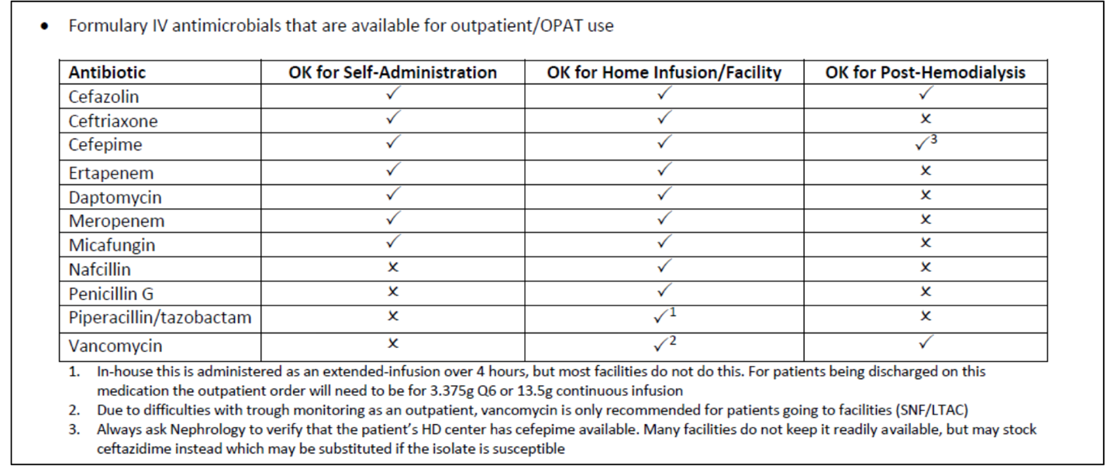
Post-Hemodialysis Antimicrobial Dosing Recommendations
- Cefazolin 2g/2g/3g after HD with 3g dose given on last HD day of the week (Friday or Saturday)
- Cefepime 2g/2g/3g after HD with 3g dose given on last HD day of the week (Friday or Saturday)
- Ceftazidime 2g after each HD
- Vancomycin after HD (dose varies)

PHHS restricted antibiotics list and criteria for use
