Linking Problems
Epic does not currently allow direct linkage of different problems that have the same plan. There are two potential work arounds. We do recommend having all problems on the problem list to support clinical decision support. However, after that either of the following will work to allow grouping for the purposes of writing A/P:
- When you write your plan start with Assessment and then include all the problems. For example: Septic shock secondary to pneumonia complicated by GNR bacteremia and lactic acidosis. Or - Septic Shock, #pneumonia, #GNR bacteremia, #lactic acidosis
- Open the problem, click details and then change the display name. with the above example, the base problem is Septic Shock. The display name becomes: Septic shock secondary to pneumonia complicated by GNR bacteremia and lactic acidosis
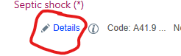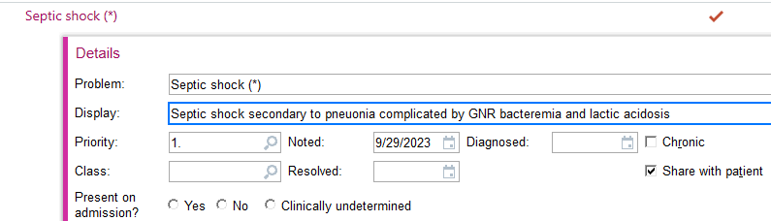

Subjective/Objective Section Issues – pull forward of prior day, doesn’t like notewriter physical
- Autocollapse the last subjective and objective to reduce scrolling – we are investigating this. In the meantime the double arrows on the top right will collapse that section 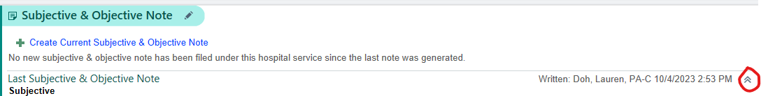
- Pull forward the prior day subjective and objective – This is possible see below 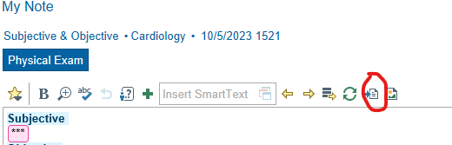
Clicking the button above will open a window the prior subj/obj note and then select the one you would like to pull forward.
- Notewriter Physical – consider making exam macros. They are a very efficient way to document a physical. See the tipsheet on that for more details.
Admission
There was a desire to see details from prior admits when deciding on which problem to use for similar problems when reconciling the problem list. It is possible to see the prior overview section in the problem list activity. In the main problem list activity (red circle), select the wrench (blue circle) and then select all or paragraph under overview preview (green circle). These setting swill persist after the change:
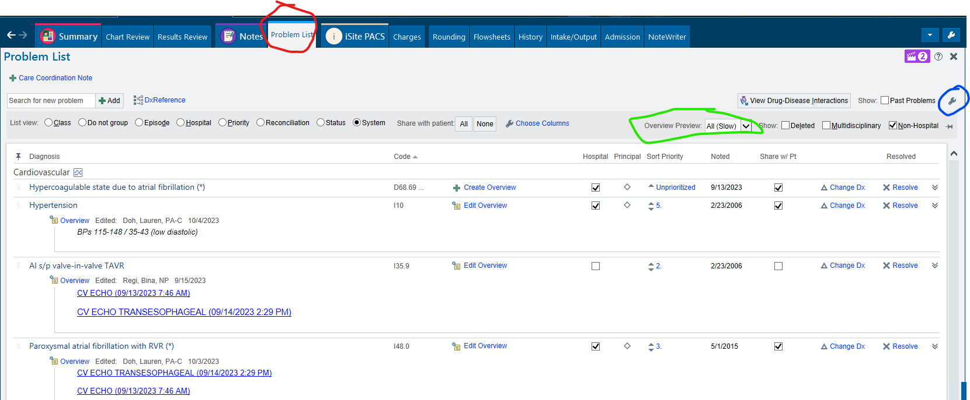
Purpose
Confusion on the genesis for the note change. The new note template was developed primarily to support quality. Specifically to support our ability to deliver the correct clinical decision support for the patient at the right time in the provider workflow. Secondary goals include reducing note bloat by taking advantage of the new billing rules.

Problem Prioritization
Several residents noted the ability to prioritize problems is suboptimal. May suggested a drag and drop approach or at least for EPIC to automatically renumber when a new number 1 or 2 is added. We agree!!!! Unfortunately, EPIC doesn’t currently support this functionality. It is a request we made to Wisconsin. In the meantime, we do sanction allowing more than one problem to have the same priority. We realize this is suboptimal but our opinion is that it’s better than reworking the entire list. In addition, we recommend setting up the sidebar as shown below (use the wrench in the green circle to access). This will reduce clutter and automatically order the problems in the sidebar according to the priority you chose: sort by priority (red circle) and leave deleted, multidisciplinary and non-hospital unchecked (blue circle):
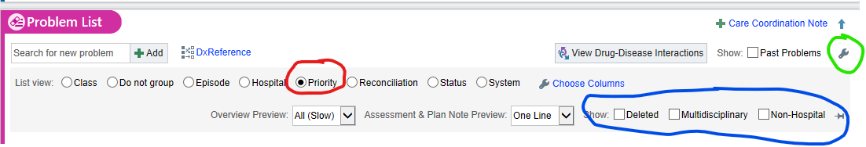

Editing an already signed note – how to add a problem to that note without reclicking everything?
This is possible. In the notes section navigate to your note and select addendum or edit. This will open the note. Then right click on the section you would like to edit and select make text editable. This will allow you to make changes. Please note that if you change a plan and you want the change to autopopulate in tomorrow’s note you will need to copy the changes made and paste them into the problem on the sidebar.
Include the Overview in the H&P as well as the DC summary
The Overview of each problem is already included in the DC summary automatically. To get to this please use the Discharge Navigator (red circle). The navigator will allow you to reconcile the meds and problems, enter DC instructions, etc. When you are ready to write the note, select Discharge Summary on the left (green circle). This will generate the DC summary note and will automatically include the Overview and most recent assessment and plan for each active hospital problem and the Overview for each resolved hospital problem. Thank you for the suggestion to automatically include the overview in the H&P. we will take that suggestion back to the project team for consideration.
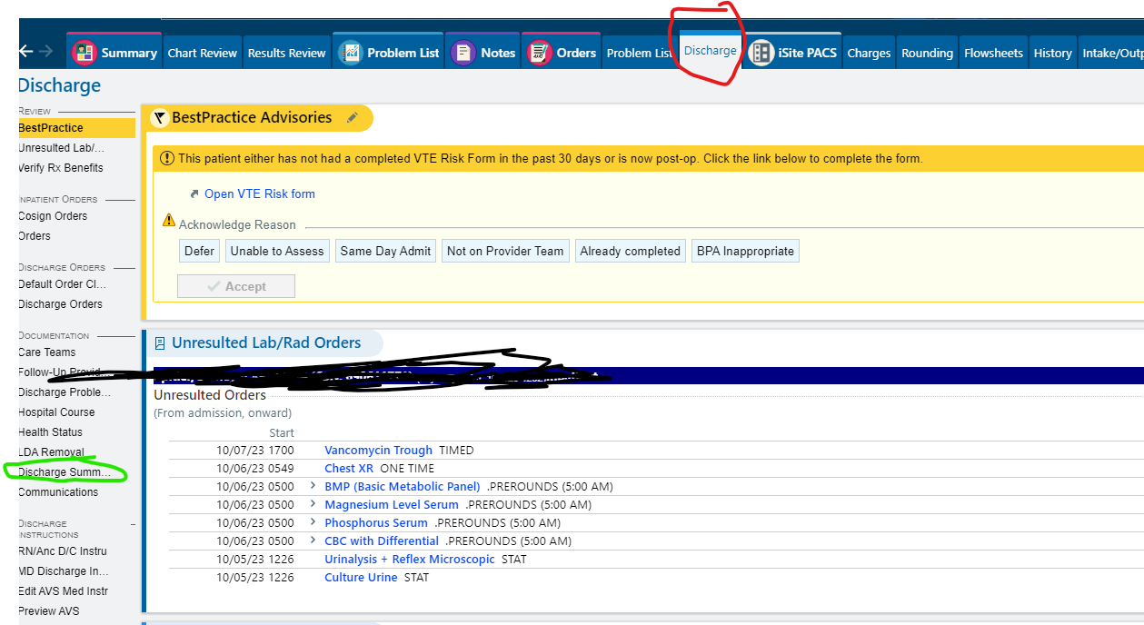
Automatically include the Principal Problem in all notes
We will investigate whether this is possible and if it is we will discuss it with the project team.
Where to include daily updates or plan?
We will discuss this with the project team and develop some options to share with the residency for consideration.
Various comments on the theme of wanting an easy way to see all the problems at once with the latest A/P
The ability to easily see all the active hospital problems and the latest assessment and plan easily has been a consistent request. We are investigating some options that would fill this need. We will report back to the residency once we have a solution.
How do you determine what is copied when reading a note
This is possible for any note. On the top right of any note select the symbol (red circle). This opens a menu and you can make your choices there. Your selections will remain your default for other notes.
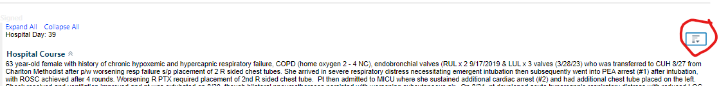
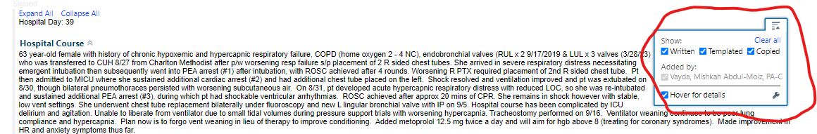

Shrinking the meds and labs in problems to reduce scrolling
EPIC has added meds and labs to the problems within the problem list primarily to make it easier to see important labs and therapies on the outpatient side. Unfortunately, this is much less useful on the inpatient side and it is leading to extra scrolling. We have asked EPIC to make what is visible something the user controls. In the meantime we are investigating whether or not we can eliminate the labs. Also, changing the following settings can significantly reduce the amount of screen real estate taken up by the medications:
The default view. Select the wrench below the Relevant medications label: 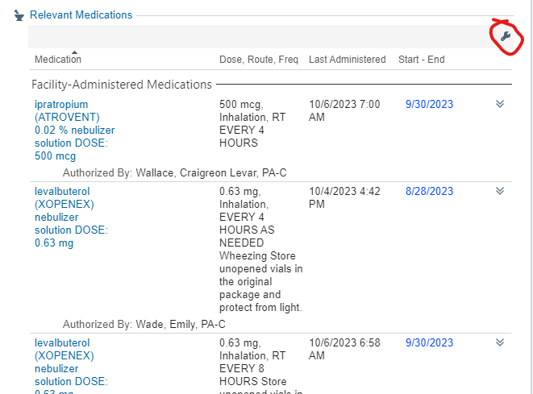
Then open the choose columns and unselect all the columns: 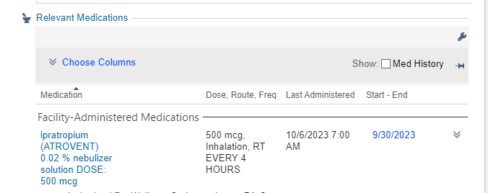
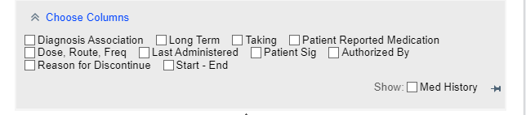This will change the view to a simple med list that takes up much less screen real estate. Your settings change will remain for your other patients.
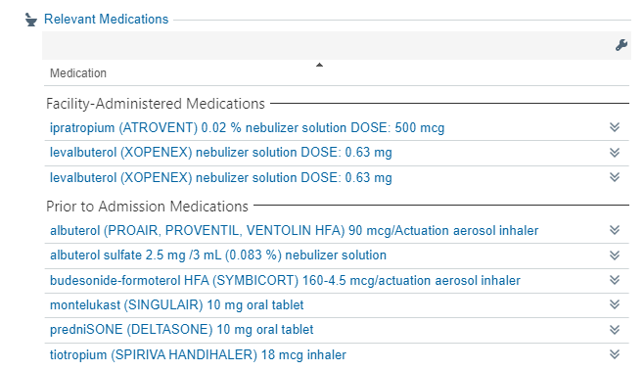

How to view problem dates
We agree that being able to view the date a problem was placed on the problem list is very helpful to determine if it’s likely to be active. It’s especially important when first evaluating a patient. You can see the dates on both the main problem list activity and in the Review Problem List section of the Admission Navigator. To do so open the wrench (red circle) and select Exact Dates (blue circle). The dates will then be visible in the Noted column (green circle). 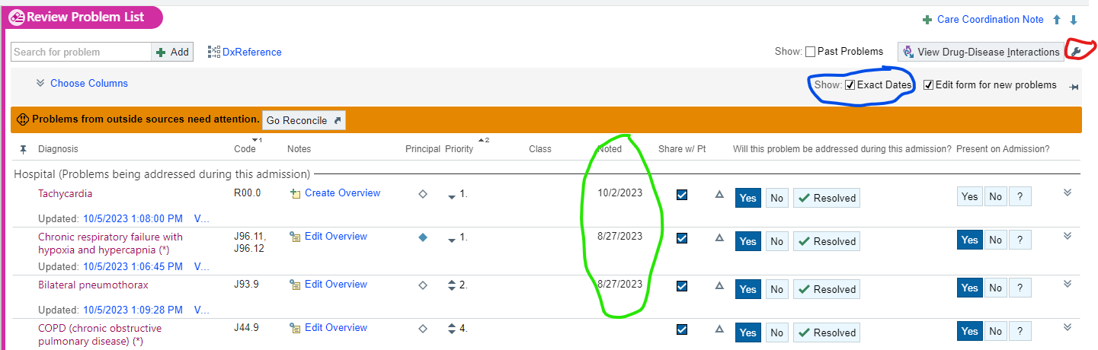
Reduce the number of clicks to get a problem included in a note
One of the easiest ways to do this is to use the Next button once you have completed writing your assessment and plan for a problem. This automatically opens the Assessment and Plan box for the next problem on the Problem list. Also, if the plan hasn’t changed selecting next will include that problem in the note without having to make a change within the box itself. 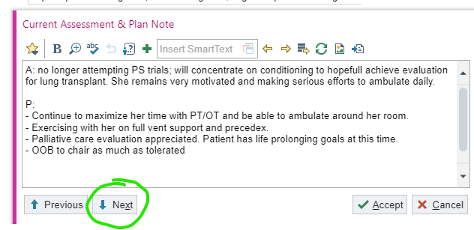
Editing Directly in the note and selecting problems with a click
This functionality is coming. EPIC is working on something called Diagnosis Aware Notes. We are told it’s about a year away.

Additional hands-on training – potentially in noon lecture with people having computers?
We will pass on the request to Residency leadership. We are also trying to arrange more at the elbow support especially at the beginning of rotations

Things we need examples of to troubleshoot
- Someone said deleted problems are showing up in the note. That shouldn’t happen so example would be helpful to troubleshoot
- Have the service context independent from the Handoff as they are having to switch contexts when going between the tabs
- Work erased by another team
- Trouble finding appropriate problems and spending time on that

